**Binary**

**TOTAL POINTS 5**

1.Question 1

Which of these is a valid byte? Check all that apply.

**1 / 1 point**



00000000

**Correct**

Great job! A byte is composed of eight bits of zeros and ones.



10022011



11011011

**Correct**

Great job! A byte is composed of eight bits of zeros and ones.



11100

2.Question 2

How many possible values can we have with 8 bits?

**1 / 1 point**



127



256



8



1 byte

**Correct**

Great job! Bits use the binary system, which is also known as the base-2 numeral system. So 2^8 allows us 256 values from 0 to 255.

Ans 2

3.Question 3

Why did UTF-8 replace the ASCII character-encoding standard?

**1 / 1 point**



UTF-8 can store a character in more than one byte.



UTF-8 only uses 128 values.



ASCII can represent emoji.



ASCII can store a character in more than one byte.

**Correct**

Wohoo! UTF-8 replaced the ASCII character-encoding standard because it can store a character in more than a single byte. This allowed us to represent a lot more character types, like emoji.

Ans 1

4.Question 4

What is the highest decimal value we can represent with a byte?

**1 / 1 point**



255



2



Any number



256

**Correct**

Correct! There are 256 values in a byte, from the decimal number 0 to 255.

Ans 1

5.Question 5

The binary value of the ASCII letter "c" is 0110 0011. Using the handy chart that we learned in the lesson, convert this number to its decimal value. You'll need to use some math for this question.

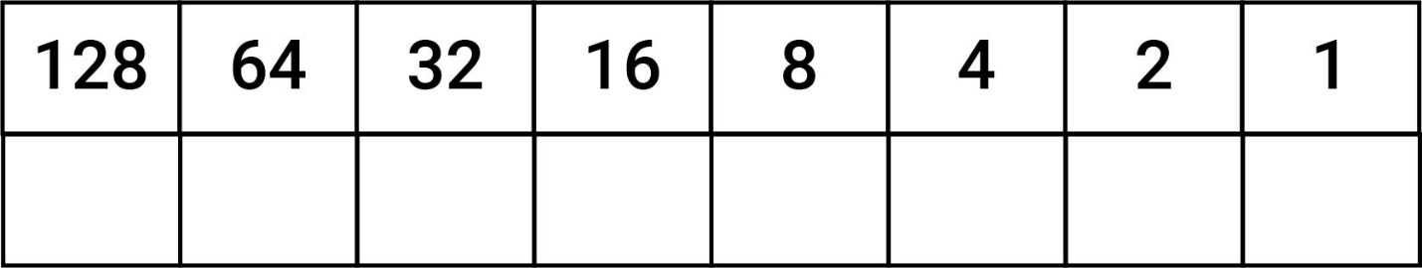

**1 / 1 point**



99



100



123



45

**Correct**

Great job! The decimal value 99 is same as the binary value 0110 0011. So the numbers that are turned ON are 64, 32, 2, and 1 and added up together. In other words, 64 + 32 + 2 + 1 = 99.

Ans 1